Ex.no:5b | DATA VISUALIZATION USING MATPLOTLIB –  SALES DATA

Aim:
To visualize the features and distributions of the Diabetes Prediction dataset using scatter plots, box plots, heatmaps, count plots, histograms, pie charts, bar charts, pair plots, bubble charts, and violin plots using Matplotlib and Seaborn.
Algorithm:
ALGORITHM 1: SCATTER PLOT
Objective: To visualize the relationship between HbA1c level and blood glucose level.
Steps
- Load the Diabetes Prediction dataset.
- Select HbA1c_level as the X-axis variable.
- Select blood_glucose_level as the Y-axis variable.
- Create a scatter plot.
- Add title and axis labels.
- Display the graph.
Interpretation
The scatter plot shows the relationship and variation between HbA1c level and blood glucose level.
Program 1: Scatter Plot
plt.figure(figsize=(8,5))

sns.scatterplot(
data=df,
x="HbA1c_level",
y="blood_glucose_level"
)

plt.title("HbA1c Level vs Blood Glucose Level")
plt.xlabel("HbA1c Level")
plt.ylabel("Blood Glucose Level")

plt.show()

ALGORITHM 2: BOX PLOT
Objective: To identify outliers in blood glucose levels.
Steps
- Select the blood_glucose_level column.
- Create a box plot.
- Add a suitable title.
- Display the plot.
Interpretation
The box plot represents the distribution of blood glucose levels and helps identify possible outliers.
Program 2: Box Plot
plt.figure(figsize=(8,5))

sns.boxplot(x=df["blood_glucose_level"])

plt.title("Blood Glucose Level Outlier Detection")

plt.show()

ALGORITHM 3: CORRELATION HEATMAP
Objective: To visualize the correlation between diabetes-related numerical attributes.
Steps
- Select the required numerical attributes.
- Calculate the correlation matrix using corr().
- Create a heatmap.
- Display the correlation values.
- Add a suitable title.
- Display the graph.
Interpretation
The correlation heatmap shows the strength and direction of relationships between the selected diabetes-related attributes.
Program 3: Correlation Heatmap
plt.figure(figsize=(10,7))

corr = df[
[
"age",
"hypertension",
"heart_disease",
"bmi",
"HbA1c_level",
"blood_glucose_level",
"diabetes"
]
].corr()

sns.heatmap(
corr,
annot=True,
cmap="coolwarm"
)

plt.title("Diabetes Dataset Correlation Heatmap")

plt.show()

ALGORITHM 4: COUNT PLOT
Objective: To visualize the number of diabetic and non-diabetic records.
Steps
- Select the diabetes column.
- Count the different diabetes categories.
- Create a count plot.
- Add title and axis labels.
- Display the graph.
Interpretation
The count plot shows the number of records belonging to each diabetes category.
Program 4: Count Plot
plt.figure(figsize=(8,5))

sns.countplot(
data=df,
x="diabetes"
)

plt.title("Diabetes Categories")
plt.xlabel("Diabetes")
plt.ylabel("Count")

plt.show()

ALGORITHM 5: HISTOGRAM
Objective: To visualize the distribution of age.
Steps
- Select the age column.
- Divide the age values into bins.
- Create a histogram.
- Add title and axis labels.
- Display the histogram.
Interpretation
The histogram shows the frequency distribution of different age groups in the dataset.
Program 5: Histogram
plt.figure(figsize=(12,5))

plt.hist(
df["age"],
bins=30
)

plt.title("Age Distribution")
plt.xlabel("Age")
plt.ylabel("Frequency")

plt.show()

ALGORITHM 6: PIE CHART
Objective: To visualize the distribution of diabetes categories.
Steps
- Count the values in the diabetes column.
- Store the category counts.
- Create a pie chart.
- Add percentage labels.
- Add a suitable title.
- Display the chart.
Interpretation
The pie chart shows the percentage distribution of diabetic and non-diabetic records.
Program 6: Pie Chart
diabetes = df["diabetes"].value_counts()

plt.figure(figsize=(8,8))

plt.pie(
diabetes,
labels=["No Diabetes", "Diabetes"],
autopct="%1.1f%%",
startangle=90
)

plt.title("Diabetes Distribution")

plt.show()

ALGORITHM 7: BAR CHART
Objective: To compare the average blood glucose level between genders.
Steps
- Group the dataset based on gender.
- Calculate the average blood_glucose_level.
- Sort the values in descending order.
- Create a bar chart.
- Add title and axis labels.
- Display the graph.
Interpretation
The bar chart compares the average blood glucose level across different genders.
Program 7: Bar Chart
gender = df.groupby("gender")["blood_glucose_level"].mean()

gender = gender.sort_values(
ascending=False
)

plt.figure(figsize=(8,5))

gender.plot(kind="bar")

plt.title("Average Blood Glucose Level by Gender")

plt.ylabel("Average Blood Glucose Level")

plt.show()

ALGORITHM 8: HISTOGRAM WITH KDE
Objective: To visualize the distribution of blood glucose levels.
Steps
- Select the blood_glucose_level column.
- Divide the values into bins.
- Create a histogram with KDE.
- Add a suitable title.
- Display the graph.
Interpretation
The histogram shows the distribution pattern of blood glucose levels in the dataset.
Program 8: Blood Glucose Distribution
plt.figure(figsize=(8,5))

sns.histplot(
df["blood_glucose_level"],
bins=30,
kde=True
)

plt.title("Blood Glucose Level Distribution")

plt.show()

ALGORITHM 9: PAIR PLOT
Objective: To visualize pairwise relationships among diabetes-related attributes.
Steps
- Select age, bmi, HbA1c_level, blood_glucose_level, and diabetes.
- Generate pairwise plots using pairplot().
- Display the relationships between the selected attributes.
Interpretation
The pair plot provides a combined visualization of relationships and distributions among the selected diabetes-related attributes.
Program 9: Pair Plot
sns.pairplot(
df[
[
"age",
"bmi",
"HbA1c_level",
"blood_glucose_level",
"diabetes"
]
]
)

plt.show()

ALGORITHM 10: BUBBLE CHART
Objective: To visualize the relationship between HbA1c level and blood glucose level while representing BMI and diabetes category.
Steps
- Select HbA1c_level as the X-axis.
- Select blood_glucose_level as the Y-axis.
- Use BMI to determine bubble size.
- Use diabetes category for bubble color.
- Add a color bar.
- Add title and axis labels.
- Display the chart.
Interpretation
The bubble chart visualizes the relationship between HbA1c level and blood glucose level while bubble size represents BMI and color represents diabetes category.
Program 10: Bubble Chart
plt.figure(figsize=(9,6))

plt.scatter(
df["HbA1c_level"],
df["blood_glucose_level"],
s=df["bmi"] * 5,
alpha=0.5,
c=df["diabetes"],
cmap="viridis"
)

plt.colorbar(label="Diabetes")

plt.xlabel("HbA1c Level")
plt.ylabel("Blood Glucose Level")

plt.title("Bubble Chart: HbA1c vs Blood Glucose")

plt.show()

ALGORITHM 11: VIOLIN PLOT
Objective: To visualize blood glucose distribution for different diabetes categories.
Steps
- Select diabetes as the categorical variable.
- Select blood_glucose_level as the numerical variable.
- Create a violin plot.
- Add title and axis labels.
- Display the graph.
Interpretation
The violin plot shows the distribution and density of blood glucose levels for diabetic and non-diabetic categories.
Program 11: Violin Plot
plt.figure(figsize=(10,6))

sns.violinplot(
data=df,
x="diabetes",
y="blood_glucose_level"
)

plt.title("Blood Glucose Distribution by Diabetes")

plt.xlabel("Diabetes")
plt.ylabel("Blood Glucose Level")

plt.show()

ALGORITHM 12: CATEGORY-WISE BOX PLOT
Objective: To compare blood glucose levels between diabetes categories.
Steps
- Select diabetes as the categorical variable.
- Select blood_glucose_level as the numerical variable.
- Create a box plot.
- Add title and axis labels.
- Display the graph.
Interpretation
The box plot compares the distribution of blood glucose levels between different diabetes categories and helps identify variations and outliers.
Program 12: Category-wise Box Plot
plt.figure(figsize=(10,6))

sns.boxplot(
data=df,
x="diabetes",
y="blood_glucose_level"
)

plt.title("Blood Glucose Level by Diabetes Category")

plt.xlabel("Diabetes")
plt.ylabel("Blood Glucose Level")

plt.show()

Output:

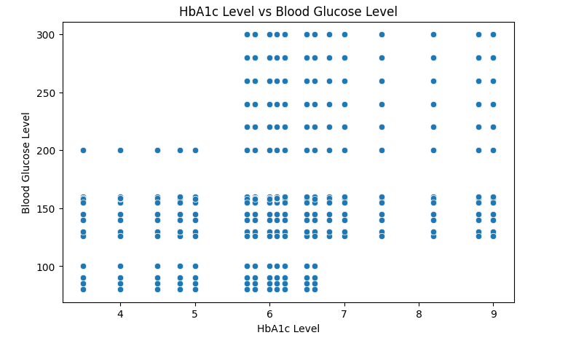
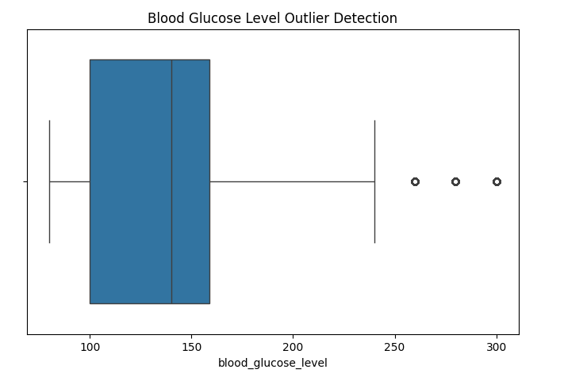
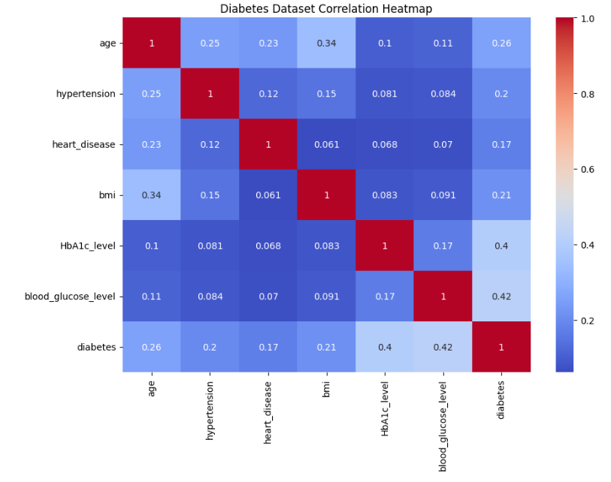
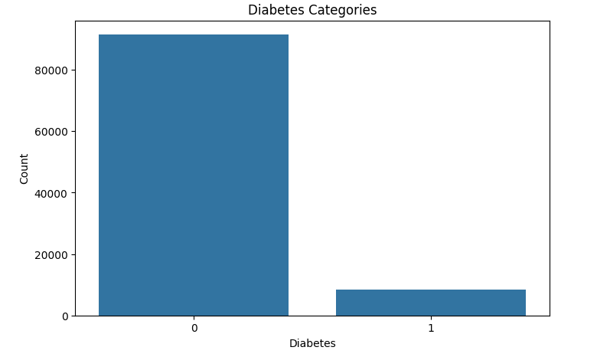

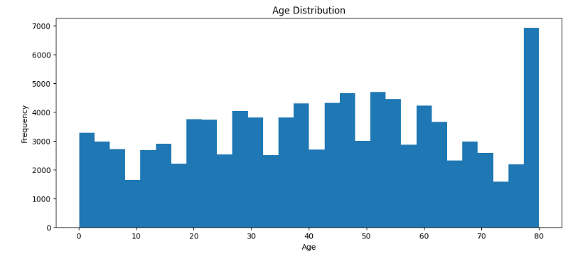
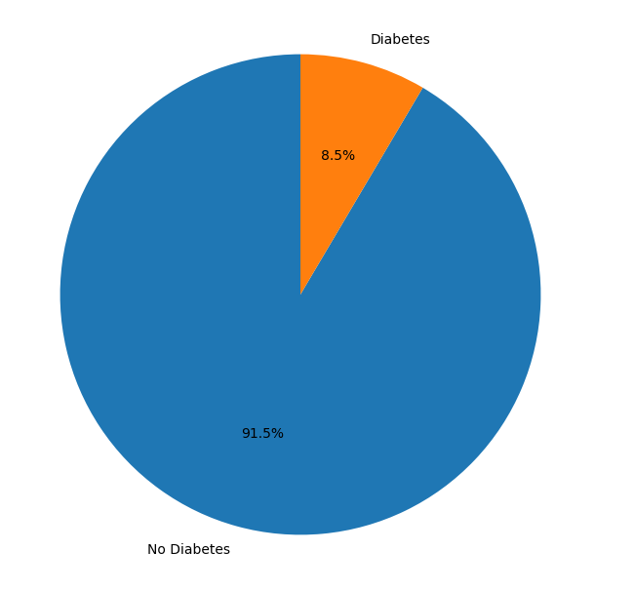
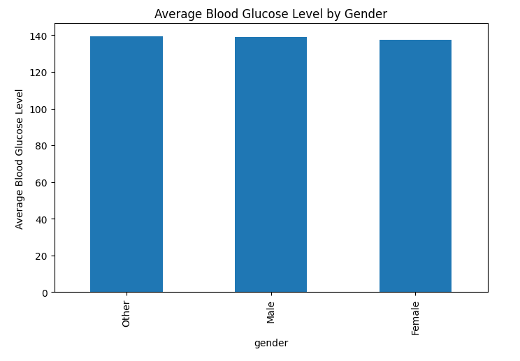
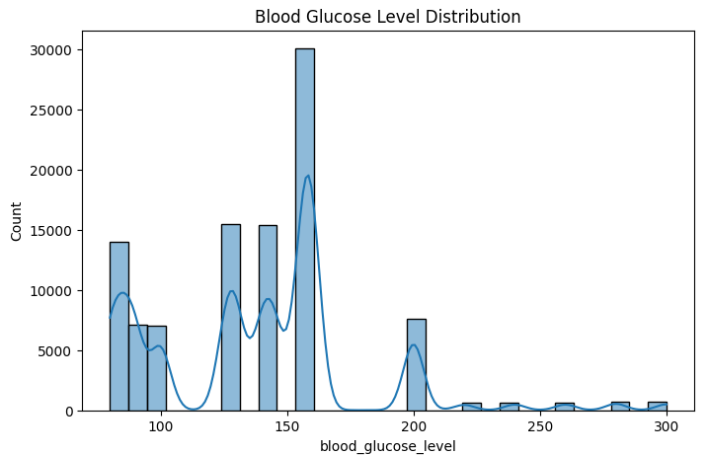

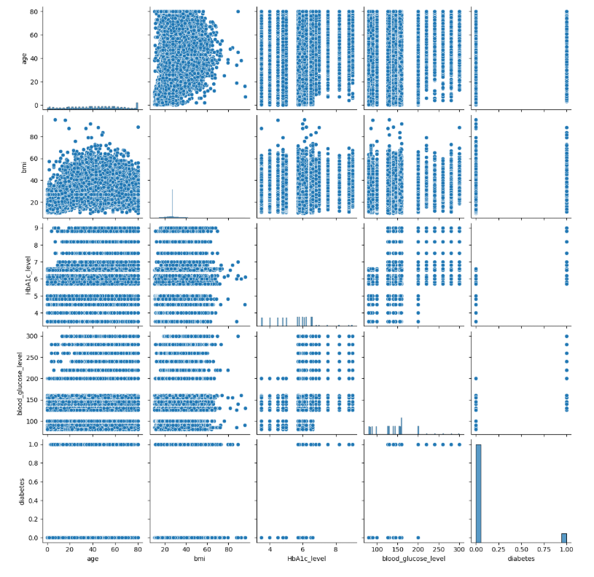
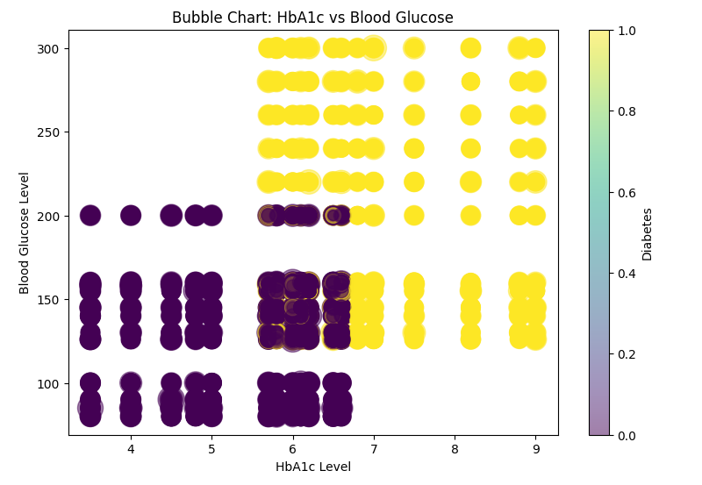
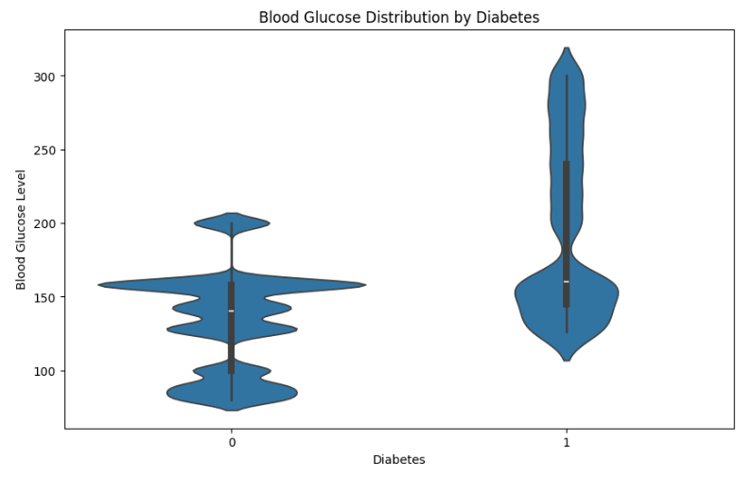

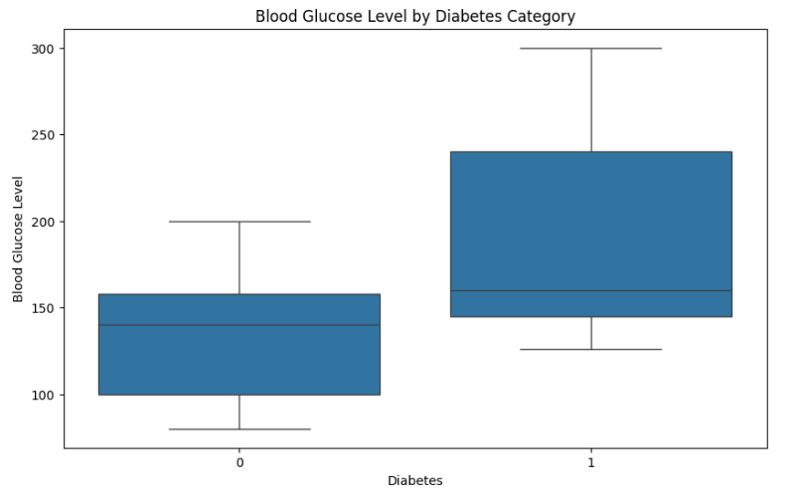
Result:

